B 22AIE111 OBJECT ORIENTED PROGRAMMING IN JAVA
S2 B.Tech CSEAI
Department of Computer Science and Engineering
Amrita School of Computing, Amritapuri Campus
CASE STUDY
PHASE – 2 (Design)
Architectural Modelling (CO2)

Group No : 2
Team Members :
Roll No | Student Name
AM.SC.U4AIE25043 | Anisetty Chandrakanth
AM.SC.U4AIE25054 | Gorti Sri Chyavan
AM.SC.U4AIE25058 | Kalagarla Pavan
AM.SC.U4AIE25059 | Kawshik Anand VS

- Problem Title : Online Food Ordering System
Introduction
This system enables users to order food digitally from restaurants.
Problem Description
Traditional ordering methods often lead to order confusion, billing errors, and delays. A digital ordering system reduces these issues by organizing ordering, payment, preparation, and delivery in one place.
Actors and Their Roles
Actor | Role
Customer | Places food orders.
Restaurant | Prepares food.
Delivery Agent | Delivers orders.
System | Tracks orders and payments.
System Workflow Narration
Customers browse menus, place food orders, and make payments online. Restaurants receive orders and prepare food accordingly. Delivery agents pick up and deliver orders to customers. The system continuously updates order status. This improves order accuracy, customer satisfaction, and also helps the system track status.

STRUCTURAL DESIGN
- Class diagram (draw a UML class diagram showing the classes and their relationships.)
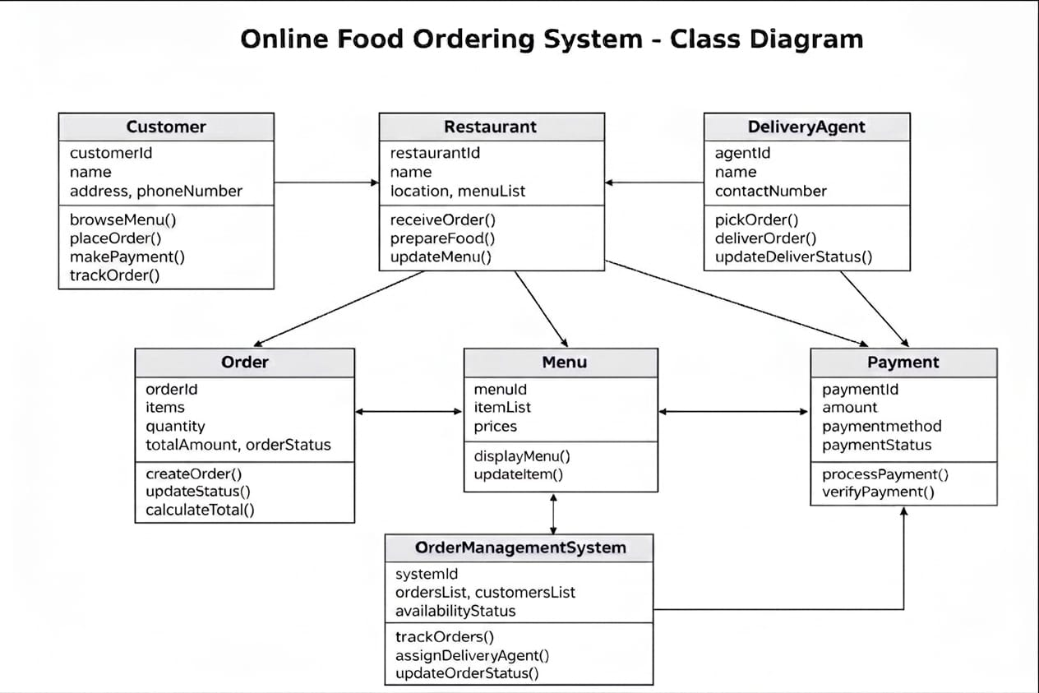
Figure 1: UML Class Diagram

BEHAVIUORAL DESIGN
- Use-case diagram
a. List of actors
1. Customer - Places food orders and views menus.
2. Restaurant - Receives orders and prepares food.
3. Delivery Agent - Picks up and delivers orders.
4. System - Tracks orders, payments, and status updates.
b. List of use-cases
1. Browse Menu - Customer views available food items and restaurant details.
2. Place Order - Customer selects food items and confirms the order.
3. Make Payment - Customer pays online using a secure payment method.
4. Accept Order - Restaurant receives and confirms the order.
5. Prepare Food - Restaurant prepares the ordered items.
6. Pick Up Order - Delivery agent collects the packed order from the restaurant.
7. Deliver Order - Delivery agent delivers the order to the customer.
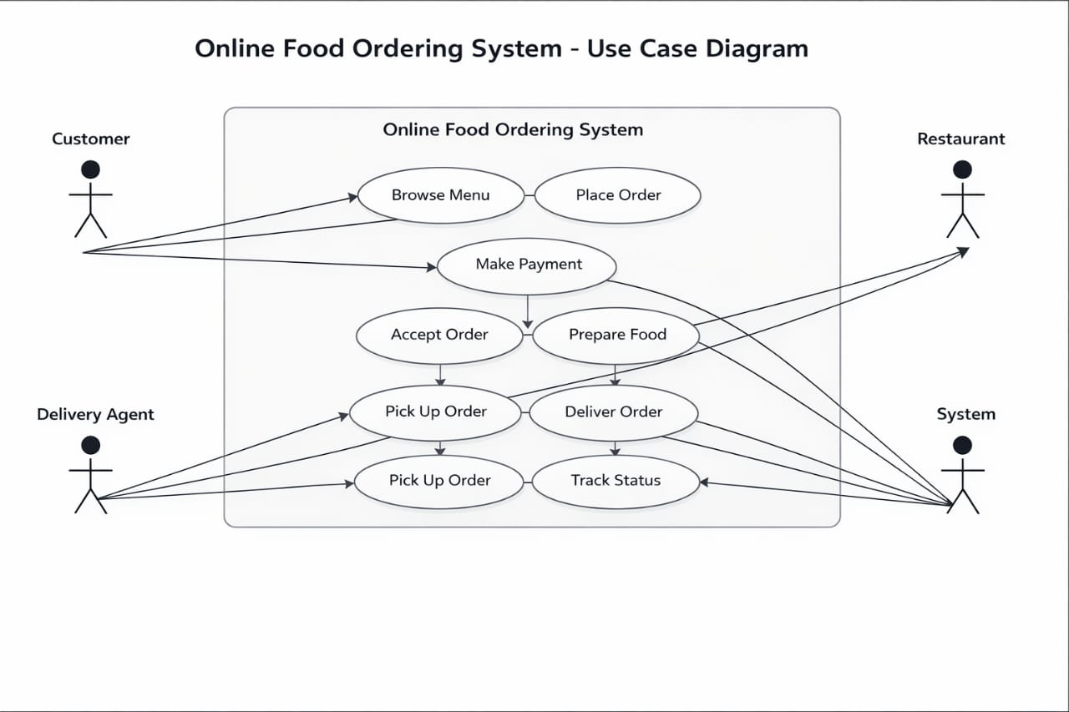
Figure 2: UML Use-Case Diagram
8. Track Order Status - System updates order progress in real time.
c. Use case diagram (use UML notations)
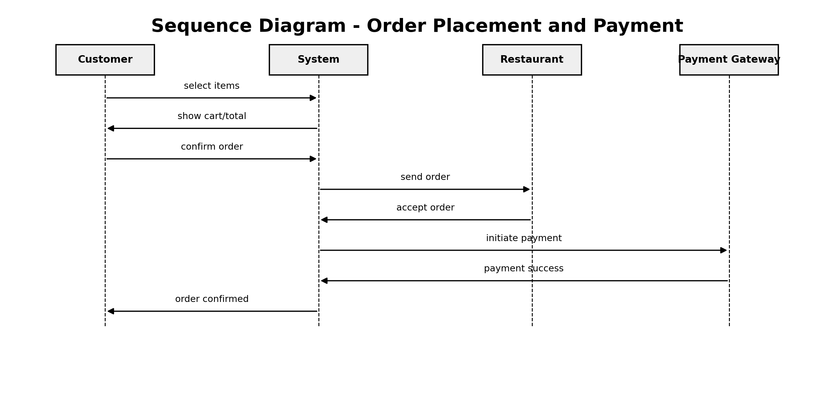
Figure 3: Sequence Diagram - Order Placement and Payment
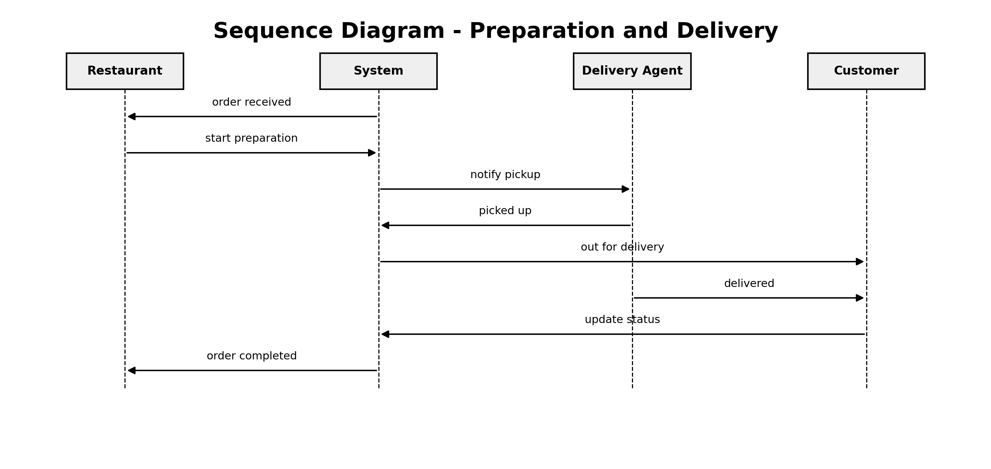
Figure 4: Sequence Diagram - Preparation and Delivery

- a. Order Placement and Payment
Customer selects food items, adds them to the cart, and confirms the order. The system records the order, processes payment, and forwards the request to the restaurant.
Customer selects food items, adds them to the cart, and confirms the order. The system records the order, processes payment, and forwards the request to the restaurant.
b. Order Preparation and Delivery
Restaurant accepts the order, prepares the food, and hands it to the delivery agent. The delivery agent delivers the order to the customer, and the system updates the status at each step.

